Authors :

[Layo Jesudhass](mailto:layolin@google.com)  ([layolin@google.com](mailto:layolin@google.com))

[Sagar Kewalramani](mailto:skewalramani@google.com) ([skewalramani@google.com](mailto:skewalramani@google.com))

**Geospatial Analytics using BQ Omni**

Multi-cloud analytics enables organizations to capitalize on the distinct capabilities of each cloud platform and extract insights and value from data sitting across multiple cloud platforms.

BigQuery Omni is a multi-cloud analytics solution that enables the analysis of data stored in other public clouds, such as Amazon Web Services (AWS) and Microsoft Azure, without the need to transfer the data to Google Cloud Platform (GCP). With BigQuery Omni, users can employ the same SQL queries and tools used to analyze data in GCP to analyze data in other clouds, making it effortless to gain insights from all data, regardless of the storage location. For businesses using multiple clouds, BigQuery Omni is an excellent tool to unify analytics and optimize the value of data.

.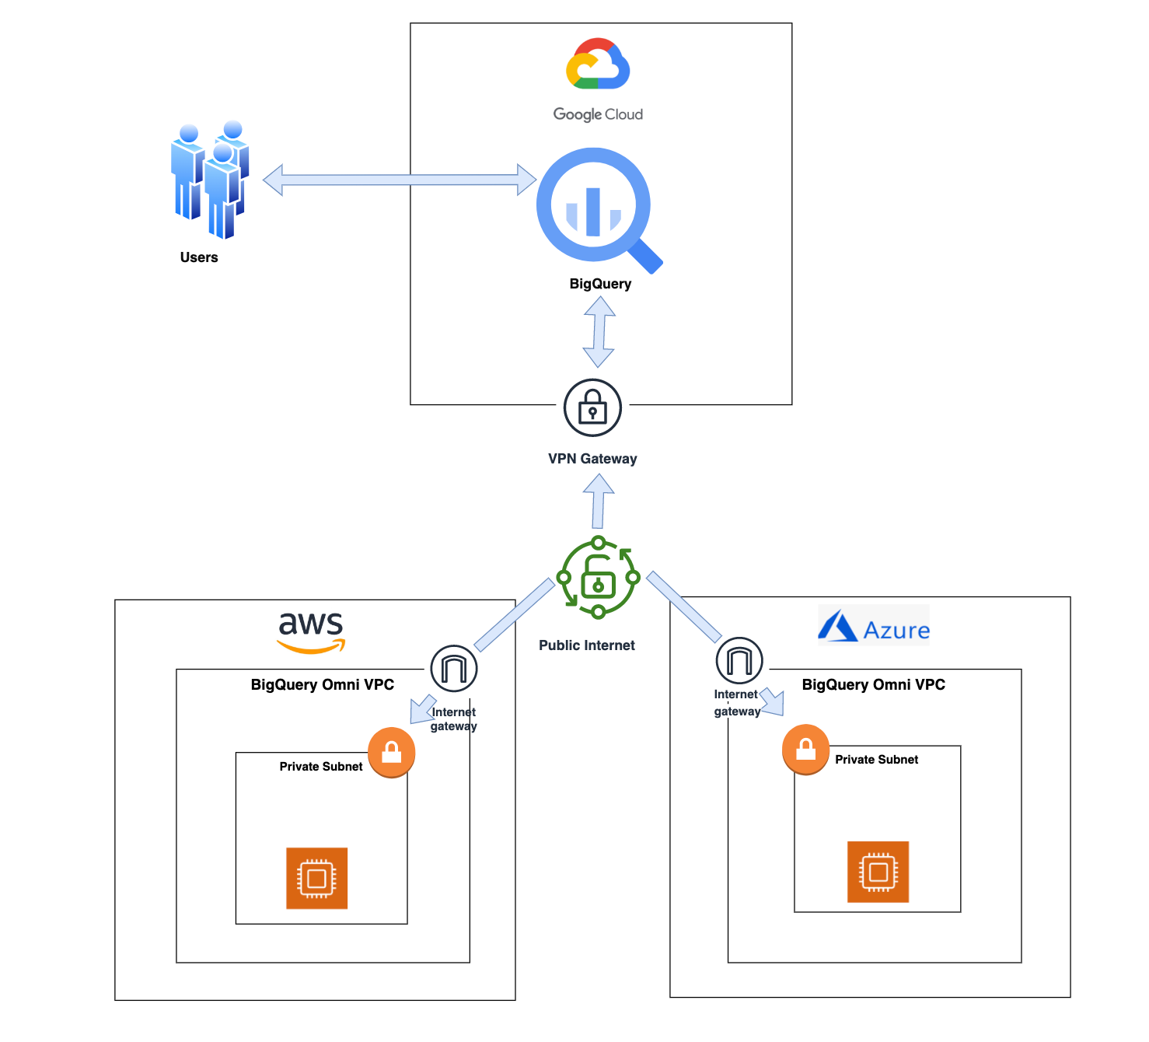

***BigQuery Omni Architecture***

One of the key features of BigQuery is its ability to analyze geospatial data. This can be especially useful for organizations that need to process large amounts of location-based data. With BigQuery Omni, organizations can analyze location-based information or geographic components, such as latitude and longitude coordinates, addresses, postal codes, or place names without even copying their data to Google Cloud. For example, you could use BigQuery Omni to analyze data from a fleet of delivery vehicles to track their location and identify potential problems.

**BQ Omni and Geospatial data analysis**

Geospatial data can be useful because it incorporates data with a geographic component, such as latitude and longitude coordinates, addresses, postal codes, or place names. This type of data can be used to track the movement of objects, identify areas of interest, and create maps. Geospatial data can be obtained from a variety of sources, including satellites, sensors, and surveys, making it an incredibly powerful tool with a broad range of applications.

As our world becomes increasingly reliant on technology to make decisions, geospatial data is becoming more critical than ever. It is a powerful resource that can be used to solve a variety of problems, from tracking the movement of goods, identifying interest areas to identifying potential areas of disaster.

If you are working with geospatial data, BigQuery Omni is a powerful tool that can help you to get insights from your data. It is scalable, reliable, and secure, making it a great option for organizations that need to unify their analytics and get the most out of their data. BigQuery Omni is an excellent choice for organizations that need to unify their analytics across multiple clouds and get the most out of their data.

Few examples,

* A transportation company could use BigQuery Omni to analyze data from GPS sensors in its vehicles to track the movement of its fleet and identify potential problems.
* A retail company could use BigQuery Omni to analyze data from its point-of-sale systems to track customer behavior and identify trends.
* A government agency could use BigQuery Omni to analyze data from its weather sensors to track the movement of storms and identify areas at risk of flooding.

BigQuery Omni and geospatial data can be used together to gain insights into a variety of business problems. Some of the advantages of using BigQuery Omni and geospatial data include:

* Increased accuracy: By analyzing data from multiple sources, BigQuery Omni can help to improve the accuracy of your insights. For example, if you are tracking the location of assets, BigQuery Omni can combine data from GPS sensors, cameras, and other sources to create a more accurate picture of their location.
* Improved efficiency: BigQuery Omni can help you to save time and money by automating the process of analyzing geospatial data. For example, you can use BigQuery Omni to create custom reports that are automatically generated based on your data.
* Enhanced decision-making: By gaining insights into your geospatial data, you can make better decisions about your business. For example, you can use BigQuery Omni to identify areas of high traffic, track the movement of assets, or create marketing campaigns that target specific locations.

**Analyzing geospatial data with BigQuery Omni**

Assume a retailer who has a large chain of department stores with locations all over the country. They were looking to expand their business and wanted to identify areas with high sales potential. They wanted a way to get a better understanding of their sales volume within specific geographic boundaries. To achieve this goal, the retailer turned to the GIS (Geographic Information System) functions built into BigQuery. Here are the steps what the retailer took to analyze this dataset:

* Step 1 : The initial orders dataset on AWS S3 contained **5.54** **million** **rows**, and there were separate locations (300 rows) & zipcode (33144 rows) metadata files on AWS S3.

**Orders Parquet files:**

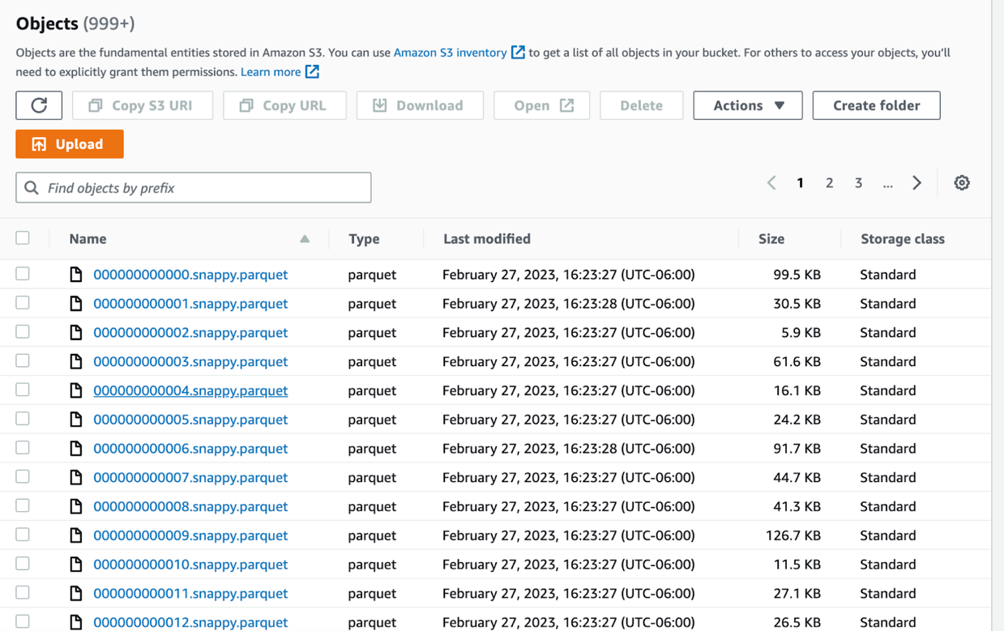

**Location and Zipcode files:**

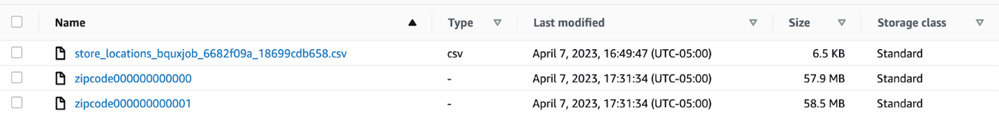

* Step  2 : We utilized BigQuery Omni to establish a connection between the data stored in AWS and BigQuery, enabling us to access the S3 datasets externally

**External Connection for AWS**

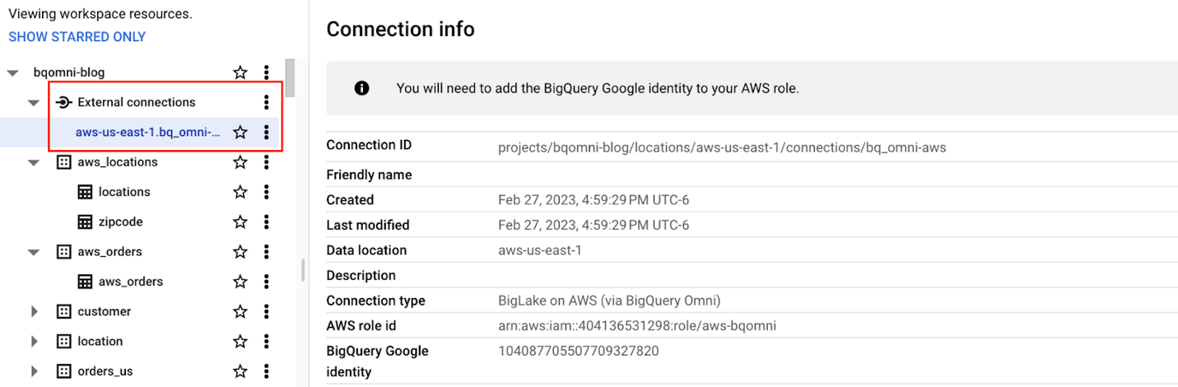

**External Table for orders**

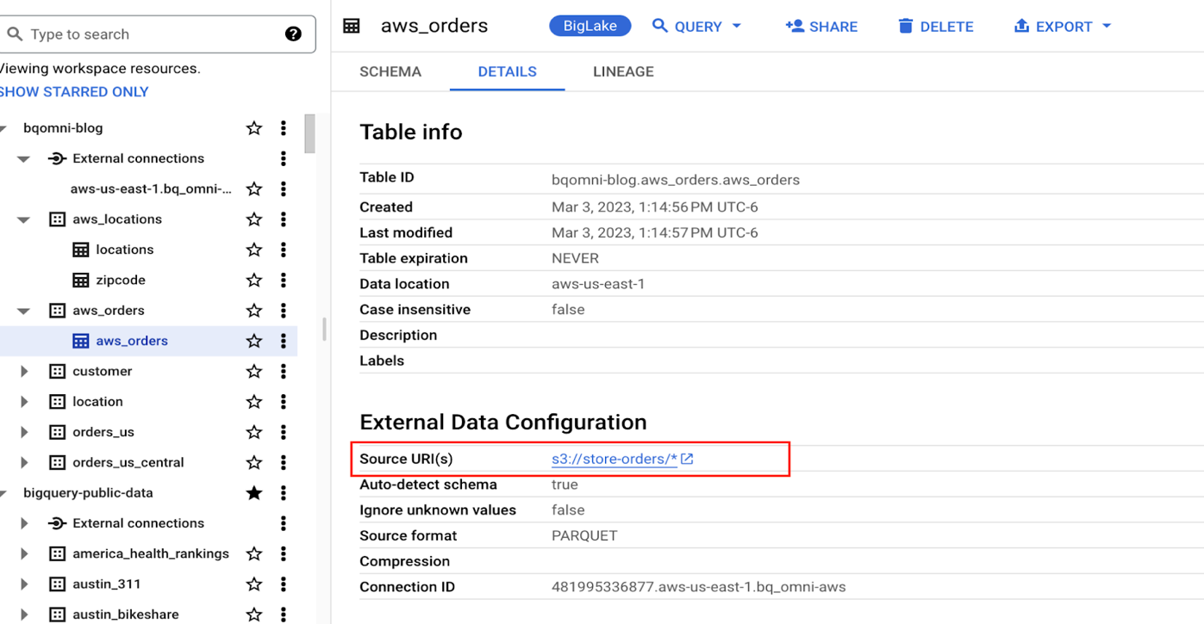

**External Table for locations**

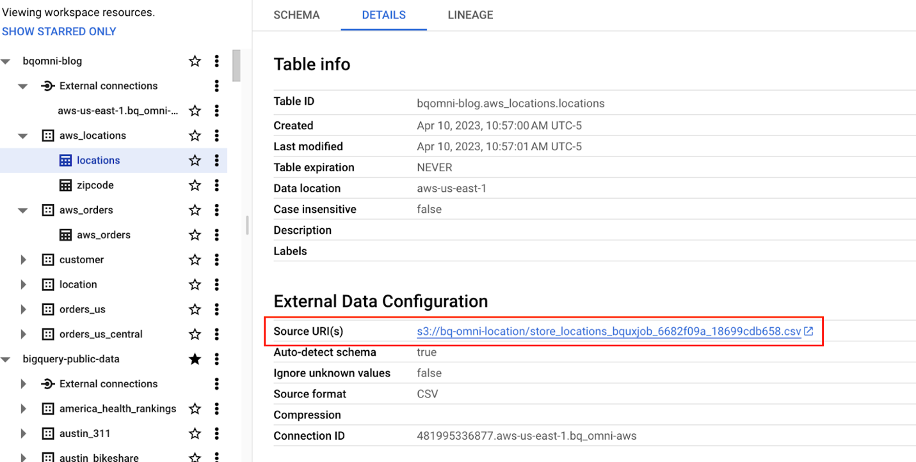

**External Table for zipcode**

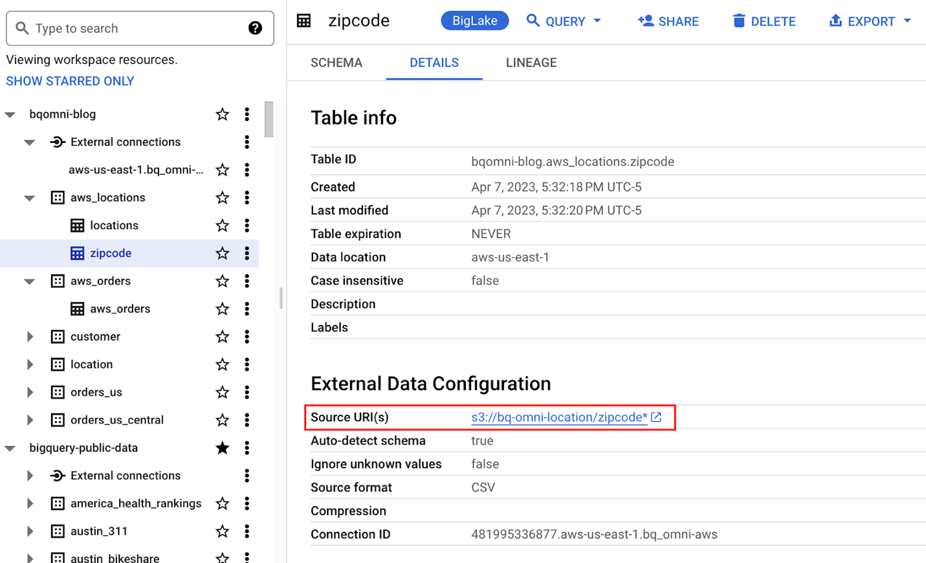

* Step 3 : We combined the Orders, locations datasets using BigQuery Omni, and remotely aggregated the data on AWS.Joining this dataset with geospatial datasets helps us to derive geo spatial coordinates
* The final aggregated dataset was reduced to 23 rows.  Subsequently, we brought back the result dataset, which contained just 23 rows. This helped us **reduce the extraction of millions of rows to just 23 rows for our Geospatial analytics**

|  |
| --- |
| **Select sales.store_city store_city,**  **sales.number_of_sales_last_10_mins number_of_sales_last_10_mins,**  **sales.store_zip store_zip,**  **ST_GeogPoint(zip_lat_lng.longitude ,**  **zip_lat_lng.latitude  ) geo**  **FROM (**  **SELECT**  **FORMAT_DATETIME("%X",**  **CURRENT_DATETIME("America/Los_Angeles")) current_time,**  **MAX(DATETIME(time_of_sale,**  **"America/Los_Angeles")) time_of_last_sale,**  **COUNT(1) number_of_sales_last_10_mins,**  **locations.city store_city,**  **locations.zip store_zip**  **FROM**  **`bqomni-blog.aws_locations.orders_small`  sales**  **JOIN**  **`bqomni-blog.aws_locations.locations` locations**  **ON**  **sales.store_id = locations.id**  **GROUP BY**  **locations.city,**  **locations.zip ) sales**  **JOIN**  **`bqomni-blog.aws_locations.zipcode` zip_lat_lng**  **ON**  **cast(sales.store_zip as INT) = cast(zip_lat_lng.zipcode as INT)**  **WHERE ST_WITHIN( ST_GeogPoint(zip_lat_lng.longitude , zip_lat_lng.latitude  ) ,ST_GeogFromText(zip_lat_lng.zipcode_geom ) )**  **AND zip_lat_lng.state_name  = "New York"**  **ORDER BY number_of_sales_last_10_mins** |

**Aggregated Sales data by region**

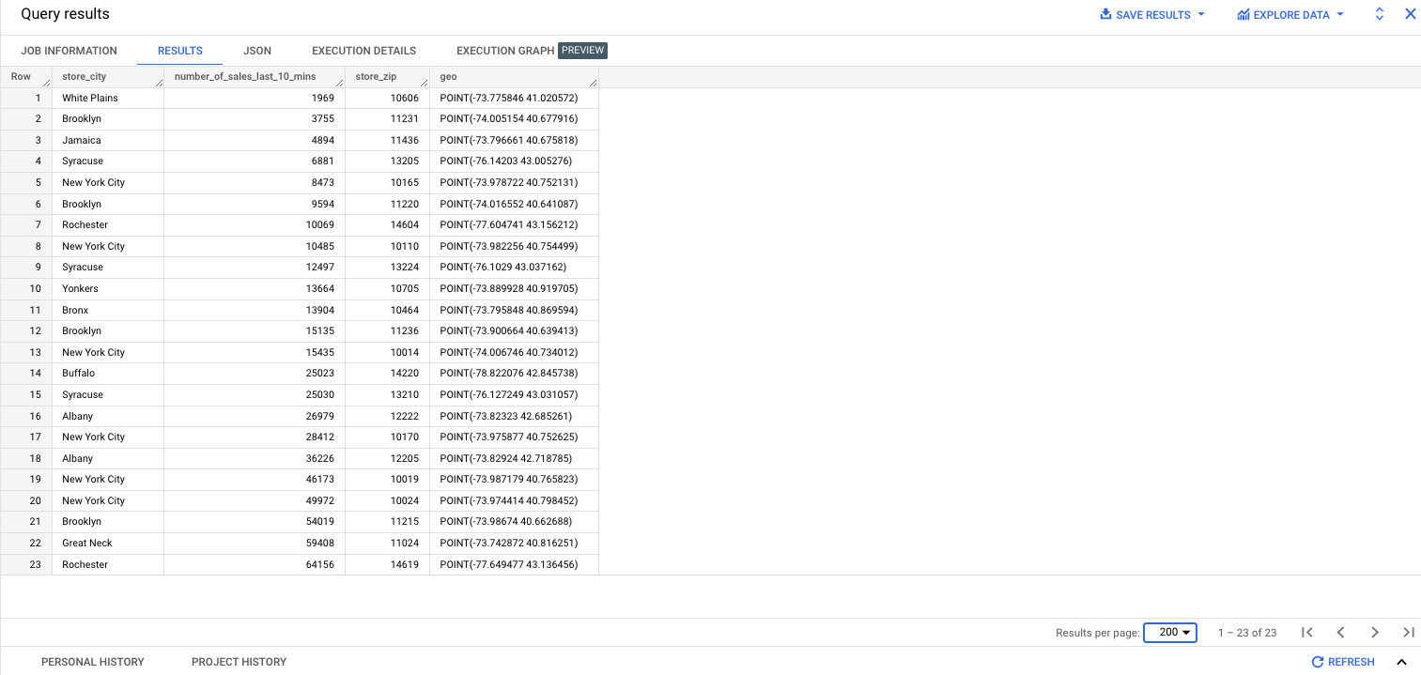

* To build richer views of their sales volume data, the retailer used BigQuery GeoViz integration, a powerful tool that allows for visualizing geographic data on maps.

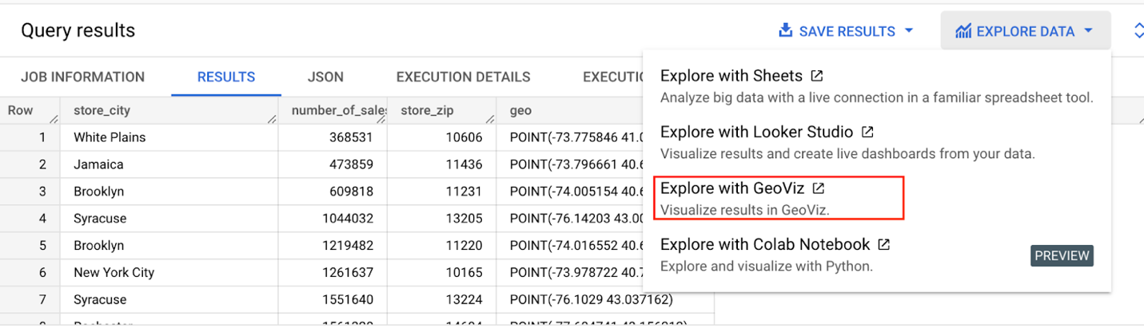

**BigQuery GeoViz view for sales data analysis**

With the geo-tagged data in place, the retailer could see  regional sales volume, sales density, distribution by department by time, and distribution within department, all powered through BigQuery.

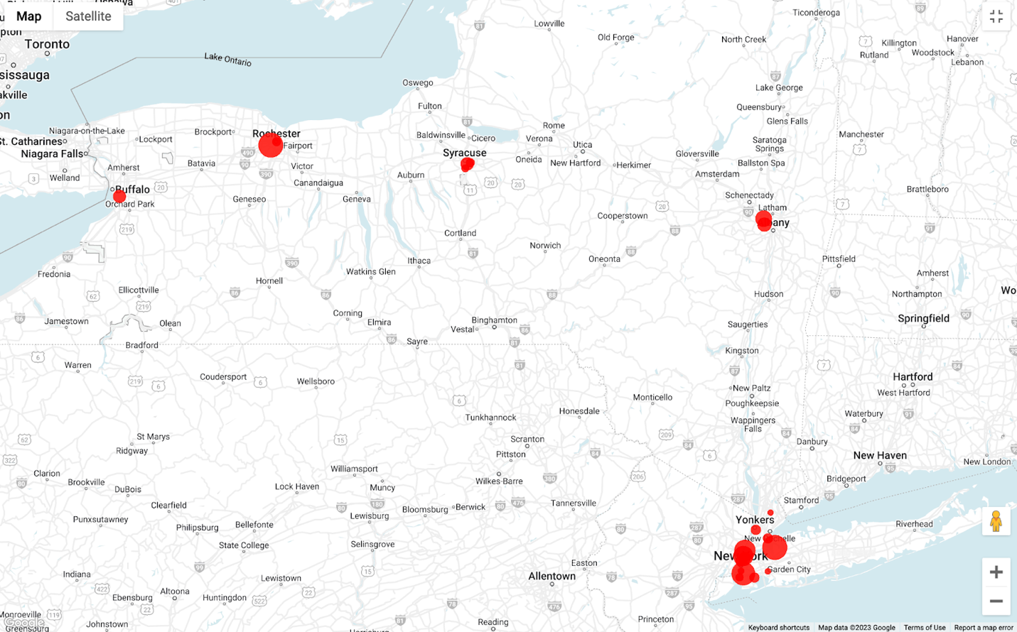

**Satellite View**

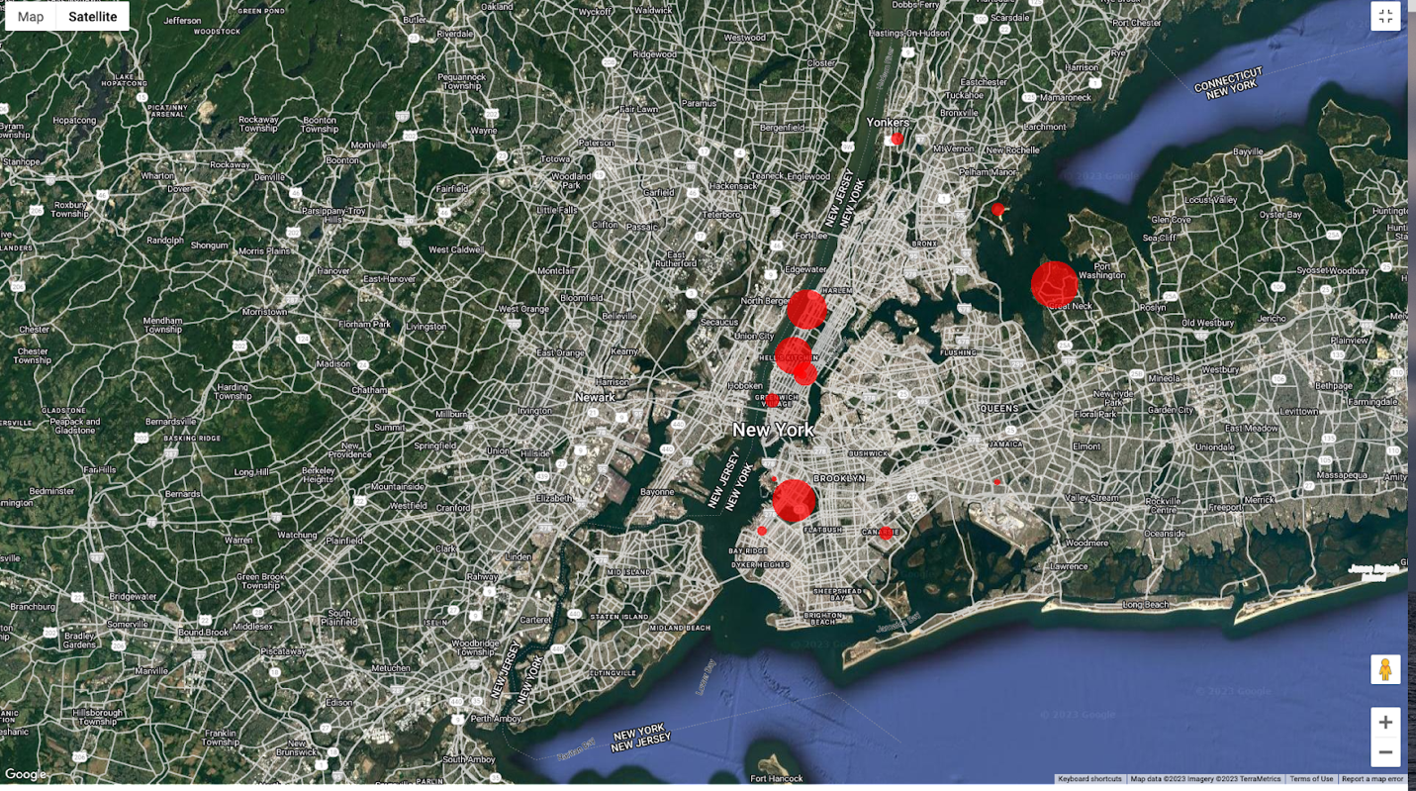

**Benefits of using BQ Omni**

BigQuery Omni is an all-inclusive analytics solution for multi-cloud environments that allows organizations to analyze data across Google Cloud, Amazon Web Services (AWS), and Microsoft Azure. It presents a unified interface to interrogate data across all three clouds, and can be utilized to analyze data residing in any supported cloud storage service.

BigQuery Omni offers a number of benefits, including:

**Reduced costs**: BigQuery Omni eliminates the need to move data between clouds, which can reduce data transfer costs and simplify data management.

**Enhanced security**: BigQuery Omni uses the same security controls as BigQuery, which includes features such as encryption, access controls, and audit logs, to help protect data from unauthorized access.

**Simplified data analysis**: BigQuery Omni provides a single interface for querying data across all three clouds, which can simplify the process of analyzing data and reduce the need for organizations to use multiple analytics tools.

**Flexibility**: BigQuery Omni can be used to analyze data stored in any of the supported cloud storage services, giving organizations the flexibility to work with the data they have regardless of where it's located.

BigQuery Omni is a valuable tool for geospatial analysis because it allows you to analyze data from multiple sources without having to move the data. This can save you time and money, and it can also help you to get more accurate insights from your data.

Overall, BigQuery Omni and geospatial data can be a powerful combination for businesses that want to gain insights into their data. If you are looking for a way to improve the accuracy, efficiency, and decision-making of your business, I encourage you to learn more about BigQuery Omni and geospatial data.

**References**

[*Omni-introduction*](https://cloud.google.com/bigquery/docs/omni-introduction)

[*Omni-benefits*](https://cloud.google.com/bigquery/docs/omni-introduction#benefits)

[*Omni-aws-create-connection*](https://cloud.google.com/bigquery/docs/omni-aws-create-connection#console)

[*Omni-azure-create-connection*](https://cloud.google.com/bigquery/docs/omni-azure-create-connection)

[*Limitations*](https://cloud.google.com/bigquery/docs/omni-introduction#limitations)

[*Omni-pricing*](https://cloud.google.com/bigquery/pricing#bqomni)

*To learn more about how BigQuery Omni can help your enterprise, check* [*here*](https://cloud.google.com/blog/products/data-analytics/analyze-data-across-clouds-with-bigquery-omni)